FELADAT


Budapest University of Technology and Economics
Faculty of Electrical Engineering and Informatics
Department of Computer Science and Information Theory

Réka Szellmann

Adaptive market Beta calculation for hedging equity portfolios

External consultant
Zoltán Papp
BUDAPEST, 2020
Academic consultant
Judit Csima
BUDAPEST, 2020
Table of Contents
Összefoglaló 5
Abstract 6
1 Introduction 7
1.1 What is market Beta and hedging? 7
1.2 The main goal 7
1.3 Structure 8
1.4 The reason behind my decision 8
1.4.1 Some statistics about trading 9
2 S&P500 + SPY Data 10
2.1 Yahoo.finance.com 10
3 Utolsó simítások 11
Irodalomjegyzék 12
Függelék 13

Hallgatói nyilatkozat
Alulírott Szellmann Réka, szigorló hallgató kijelentem, hogy ezt a szakdolgozatot meg nem engedett segítség nélkül, saját magam készítettem, csak a megadott forrásokat (szakirodalom, eszközök stb.) használtam fel. Minden olyan részt, melyet szó szerint, vagy azonos értelemben, de átfogalmazva más forrásból átvettem, egyértelműen, a forrás megadásával megjelöltem.
Hozzájárulok, hogy a jelen munkám alapadatait (szerző(k), cím, angol és magyar nyelvű tartalmi kivonat, készítés éve, konzulens(ek) neve) a BME VIK nyilvánosan hozzáférhető elektronikus formában, a munka teljes szövegét pedig az egyetem belső hálózatán keresztül (vagy hitelesített felhasználók számára) közzétegye. Kijelentem, hogy a benyújtott munka és annak elektronikus verziója megegyezik. Dékáni engedéllyel titkosított diplomatervek esetén a dolgozat szövege csak 3 év eltelte után válik hozzáférhetővé.
Kelt: Budapest, 2020. 12. 06.
...…………………………………………….
Szellmann Réka

Összefoglaló
A dolgozat célja egy olyan algoritmus létrehozása, aminek a segítségével hatékonyan meg lehet jósolni a kiválasztott papírok árát a következő időszakra. A piacban megfigyelhető trendek torzíthatják az egyes papírok mozgásának a megfigyelését, ennek a kiküszöbölésére Hedge stratégiát lehet alkalmazni, ami ebben a dolgozatban a Market Beta formájában jelenik meg.
Ahhoz, hogy pontosabb becslést tudjak adni, több béta értéket is össze kell hasonlítani, amihez a csúszóablakos módszer lesz a segítségemre. A különböző ablakok pontosságának meghatározásához egy alapvető statisztikai módszerhez nyúlok: a beta error (más néven másodfajú hiba) vizsgálatához.
Bevezetésképpen implementálok egy algoritmust, ami a Follow the Leader elvén működik, ez egy egyszerű módszer, ahol mindig az addig legjobban teljesítő értéket választom ki a következőnek.
Pontosabb becsléshez a Random Forest algoritmust használom fel, amit a papírok különböző tulajdonságainak a segítségével tanítok be, majd összevetem az eredmények hasznosságát. A kimenet teszteléséhez kiszámolom minden napra a legkisebb hibát adó ablak értékét.
A dolgozat során az S&P500 cégek részvényenek az adatait, a piac követésére a pedig az SPY indexet használom fel, a választott nyelv a Python.

Abstract
The goal of the paper is to create an algorithm which can be used to predict the selected paper’s prices for the next period.
Every stock market has a trend which can create a distortion in stocks. To avoid it I use a Hedge strategy, the Market Beta calculation.
To give a more accurate prediction I use the Sliding Windows strategy and compare its results. The accuracy can be calculated using a basic statistic method called beta (or type II) error.
At first, I implement an algorithm based on Follow the Leader. It’s a simple one-iteration method which always choose the window with the best results so far.
For more accuracy I use Random Forest and teach with different aspects of the paper, after I compare the results against each other. I calculate the best window for all days to test the window with the smallest error.
In the paper I use the stocks of S&P500 and SPY index for market. The programming language is Python.

Introduction
In this chapter I clarify the subject of the paper and why I choose it. To clarify the definitions, I choose to use Investopedia which is the world's leading source of financial content on the web.

What is market Beta and hedging?
Beta is a measure of the volatility - or systematic risk - of a security or portfolio compared to the market as a whole. It can help us to describe the movements of assets without the affection of the market’s popularity.
Generally, hedge is when we consider another asset’s (portfolio, market, instrument) value into calculation.
In this paper I use the S&P500 stocks and follow the market by using the SPY index. I intent to use hedging to neutralize the effects of the market on our stocks.

The main goal
The goal is to predict the selected stocks’ movements using market beta. To do that I need historical data: the daily returns from 2000 to 2020 which I get from yahoo.finance.com. Beta error (known as type II error from statistics) can be used to tell the accuracy of market Beta. To find the most usable data I use Sliding Window Technique with windows slides 5,10,20,50 and 60. To select the most suitable window slide I use the Follow the Leader Technique, then I teach a Random Forest Machine Learning algorithm with beta errors.

Structure
First of all I talk about the data: how to get it from Yahoo, filter out and a few world about cleaning it. I show some basic statistics with plot library.
After I show some statistics of beta error with different sliding windows.
The next step is the idea and implementation of the Follow the Leader.
The last part is the Random Forest. I try different properties for the feature vector and I show how to calculate the best window for all days.
I show statistics about the different outputs and get the conclusion about them, then calculate the feature prices with the best algorithm.

The reason behind my decision
Artificial Intelligent is one of the most popular fields nowadays, there are countless research and it still has a very large potential of developing. It can be applied for many financial problems with a huge success. Some trading company already use Machine Learning to predict the prices, reduce risk and make faster orders.
In 2020 we are facing a bigger global crisis and because of that most of the instrument’s prices are drop down. In these times trading on stock is very popular among people all over the world.

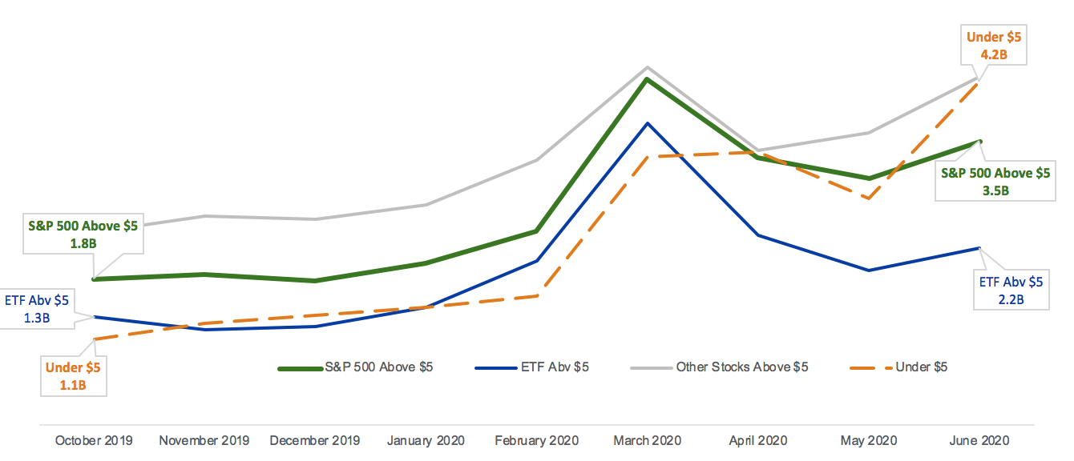
Some statistics about trading

1. US Equity Market Volume, October 2019 - June 2020
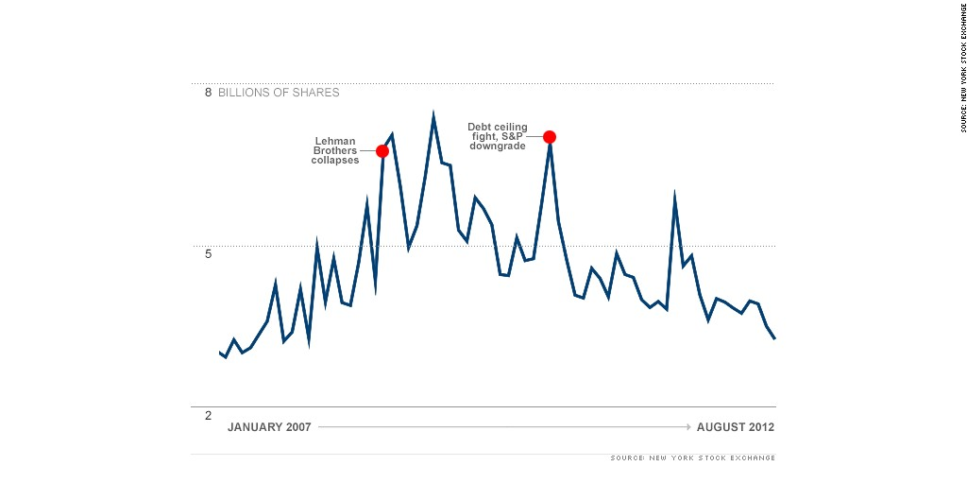
2. NYSE trading volume between 2007 and 2012

S&P500 + SPY Data

Yahoo.finance.com
The main source of my data is yahoo.finance.com, Python has an API to make it easy to use. First I get the list of actual S&P500 companies from Wikipedia, and turn data into pandas.DataFrame. I calculate the daily returns and drop the other data:
daily_return_df['Daily Return'] = (daily_return_df['Adj Close'] / daily_return_df['Open']) – 1
daily_return_df.rename(columns={'Daily Return': ticker}, inplace=True)
daily_return_df.drop(['Open', 'High', 'Low', 'Close', 'Adj Close', 'Volume'], 1, inplace=True)
and join all ticker to one DataFrame:
if main_daily_return_df.empty:
main_daily_return_df = daily_return_df
else:
main_daily_return_df = main_daily_return_df.join(daily_return_df, how='outer')
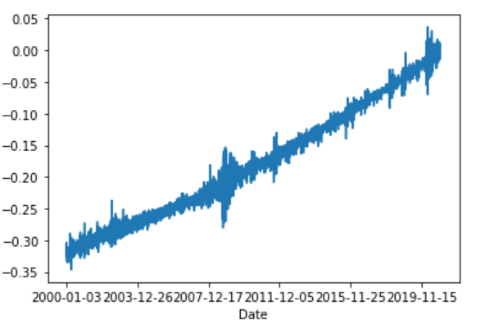

Follow the Leader

Conception
The idea of Follow the Leader method is very simple: we have a weight matrix where we can store the performance of our options, every iteration we choose the one with the best result so far and refresh the weigh:
$$w_{t}=arg min_{w∈S}\sum_{i=1}^{t-1}{v_{i}\left(w\right)}$$
It is known to perform well when the loss functions are convex and positively curved, but it can be very slow on big data.
A popular version is Follow the Regularised Leader, where we can add a regularisation:
$$w_{t}=arg min_{w∈S}\sum_{i=1}^{t-1}{v_{i}\left(w\right)}+R\left(w\right)$$

Implementation
I used the Follow the Leader algorithm to calculate beta. I iterate through all of the last 20 years’ data and find the best window in every iteration. After I calculate the performance for all window on that iteration.
The

Example from finance world
One of the practical usages of Follow the Leader conception is when we make orders based on the relations between instruments, or movements of another investor. But following the top ranked investors have a big risk, we need to be aware of that.

Bibliography
https://www.jmlr.org/papers/volume15/rooij14a/rooij14a.pdf
https://en.wikipedia.org/wiki/Online_machine_learning#Follow_the_leader_(FTL)
https://www.jmlr.org/papers/volume18/17-079/17-079.pdf
https://static.googleusercontent.com/media/research.google.com/en//pubs/archive/41159.pdf
https://courses.cs.washington.edu/courses/cse599s/14sp/scribes/lecture3/lecture3.pdf
https://medium.com/@dhirajreddy13/factorization-machines-and-follow-the-regression-leader-for-dummies-7657652dce69

https://www.investopedia.com/terms/b/beta.asp
https://www.investopedia.com/terms/b/beta-risk.asp
https://www.nyse.com/data-insights/market-volume-and-off-exchange-trading
https://money.cnn.com/2012/08/22/investing/trading-volume/index.html
https://pypi.org/project/yahoo-finance/
https://pythonprogramming.net/sp500-company-list-python-programming-for-finance/
https://pythonprogramming.net/sp500-company-price-data-python-programming-for-finance/
Journal of Machine Learning Research 18 (2017) 1-31
https://courses.cs.washington.edu/courses/cse599s/14sp/scribes/lecture3/lecture3.pdf
https://www.marketwatch.com/story/following-the-leader-is-a-losing-strategy-2018-07-09

